Programming 6212 Assignment 3

2016

Adrian Beukes 15002426

**Content**

Specifications ………………………………………………………………………..2 Purpose Functional Requirements

Test Data ………………………………………………………………………..3

Flow Chart ………………………………………………………………………..9

Class Diagram ………………………………………………………………………..10

Error Handling …………………………………………………………………….....11

Help ………………………………………………………………………..11

**Specifications:**

Purpose:

This project is to develop a patient scheduling system for a physician’s practice. I decided upon creating a program for Durban First Health. The main purpose of my program is to allow employees to log in using a security password, which can be self-selected as well as updated anytime, you do how ever need your old password as a confirmation in order to change it. Once in the program, an employee can add an appointment, with fields like name, surname, number, date and time, and a short description of why they want the appointment. They can then view all appointments that have been made, update them, delete them, or even run a search through them by using a key word as an identifier.

Added functionality was also the option to print the appointment list.

My program works on a windows form application, with the integration of inheritance and text files, databases and use that input to give the wanted outcome/reports.

Functional Requirements:

In my form you would find examples of the following

Functions from my 3rd assignment where to be able to:

* Appropriately handle of problems
* Exception handling
* User friendly feedback
* Recovery from exception being thrown

All of the above was met, with added functionality, and great design.

**Test Data**

A few screenshots of my program will follow, with explanation of what’s happening at each stage, as I progress in order to test it:

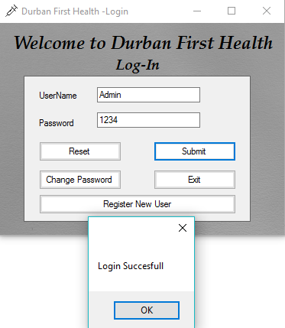

This is the Login Form, here you can sign in, reset fields in case of spelling error, or you have the option to register new users, change password, or exit the program

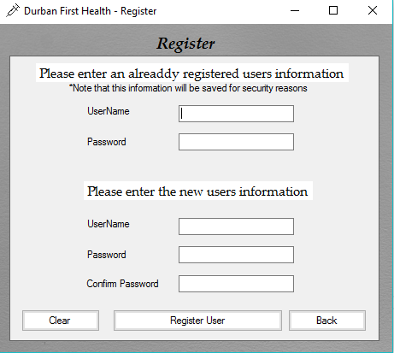

This is the register form, you need a valid user to enter information, before you can register as a new user, for security reasons, and the user registering you data will be recorder, in the case of corruption, there is also a function of retyping the password, to check that the new user has the correct password.

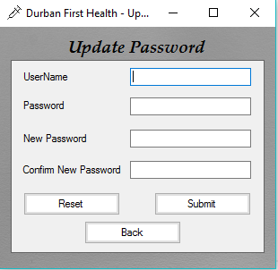

This is the Update of your password screen, where you enter your already registered information, with your desired password and a confirmation of that password, if it’s a success, your password will have changed to the new one



Splash Screen With a progress bar and percentage amount till completion

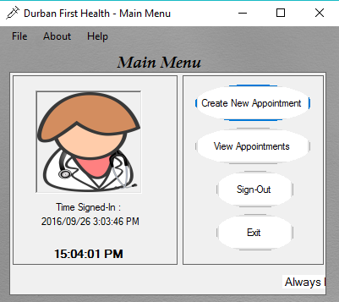

Once you successfully logged in, you will see the main menu, which gives you a menu at the top, with files in it for, log-out, exit, as well as a help and about function. On the left hand side is the profile information on when you logged in, and the current time, to see how long you have been in the Program logged on. On the right side is the buttons to create a new appointment, a view all appointments, or a search function if you’re looking for a specific person.

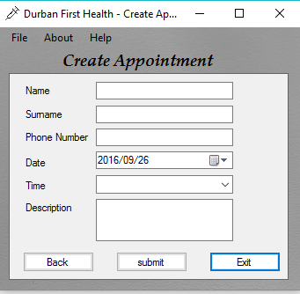

This is the fields that need entering for creating an appointment, and you do need to complete all fields with information before you can submit it

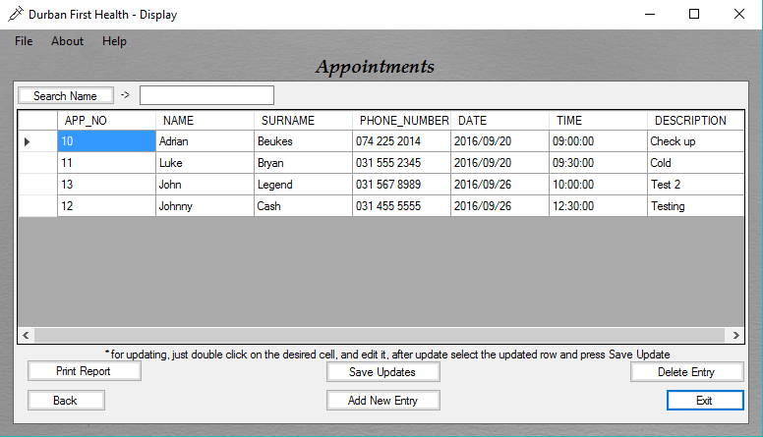

The display form, gives you all the information about the appointments, currently it is running the above search for John, from this form, you can run another search, update the information on an appointment, or completely remove the appointment, there is also the added functionality of printing the currently stored text file with all the appointments on them.

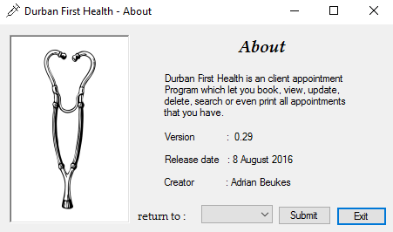

The About Form tells you a bit about the program, and from here you have the option to logout, or return to the main menu, as well as exit.

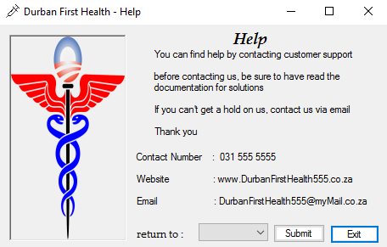

The Help form is a lot like the about, but with information of how you can get a hold of us, if you are in need of assistance.

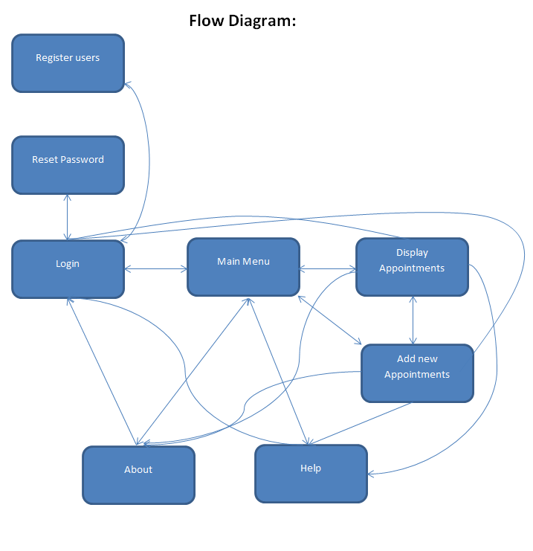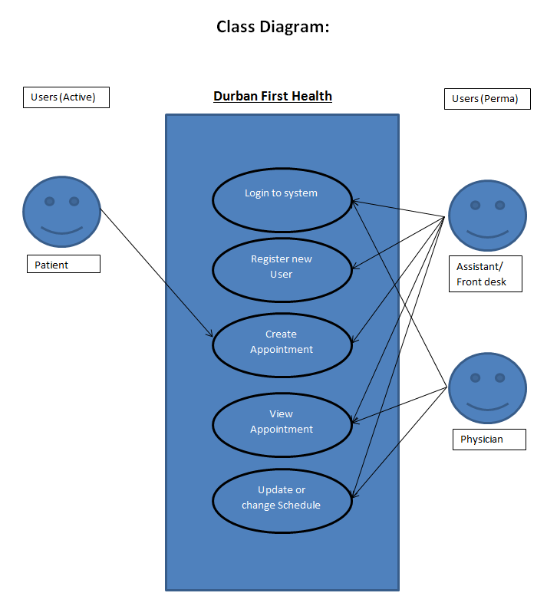

**Error Handling:**

For my error handling I added Booleans with while loops, so in case the incorrect information was entered, it will repeat asking the question

There was also if statements used to check that values entered are correct, else will tell you to correct it in a message box

The login also has catches to see if correct information is entered, and you can’t enter the program with wrong information

**Help:**

This is a guide that would take you step for step through the application.

On opening the application you will find yourself at the login page, where you have to enter the correct credentials and password to receive access to the application, else you have the option of registering a new user for the system, although, you do need a valid already registered employee to help new employee’s with registration, as there data is needed in creating the new employee data, also note their information will be stored in order to prevent any fraud. You also have the option to update your password if you are an already registered user, in the update of the password, you still need to type your old password together with the new one and a confirmation of the new one, if you’re successful, the password should have updated.

After successfully logging into the system, a splash screen will load from there you will find yourself with the main menu, where you will have the option of adding a new appointment, view all the appointments, or run a search for a specific person.

After making your selection options, the display screen with all the appointments and their information will be displayed, here you can select any appointment from the list, and update them by double clicking the desired field and type in it, then pressing save update to update the database.

In the display screen you can also find the option to delete an entry should an appointment be cancelled, or a print option, which will print the entire appointment list for you.

Each screen has a back button option which will take you to the previous screen, or exit which will terminate the application.

Each screen also has a help and about option in the menu bar, which will take you to the help and information screen and from there you can exit or return to the main menu or log-in screen

In each form you will also find a logout and exit underneath the file menu bar, which will initiate that process depending on the selected choice.